**MICROPROCESSOR AND COMPUTER ARCHITECTURE LABORATORY**

**UE19CS256**

**4TH SEMESTER, ACADEMIC YEAR 2020-21**

|  |  |  |
| --- | --- | --- |
| **Name: Atul Anurag** | **SRN: PES2UG19CS075** | **Section: B** |

**Date: 04-03-2021**

**Week#5**

Program Number: 1

**Write an ALP to display Hello World**

1. ARM Assembly Code

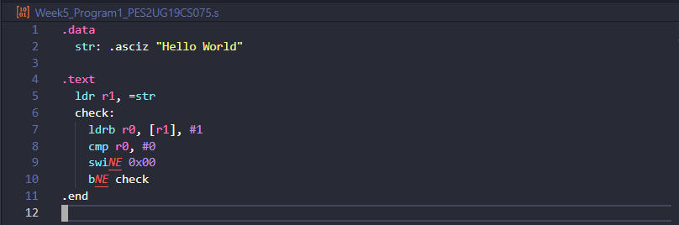

1. Output Screen Shot

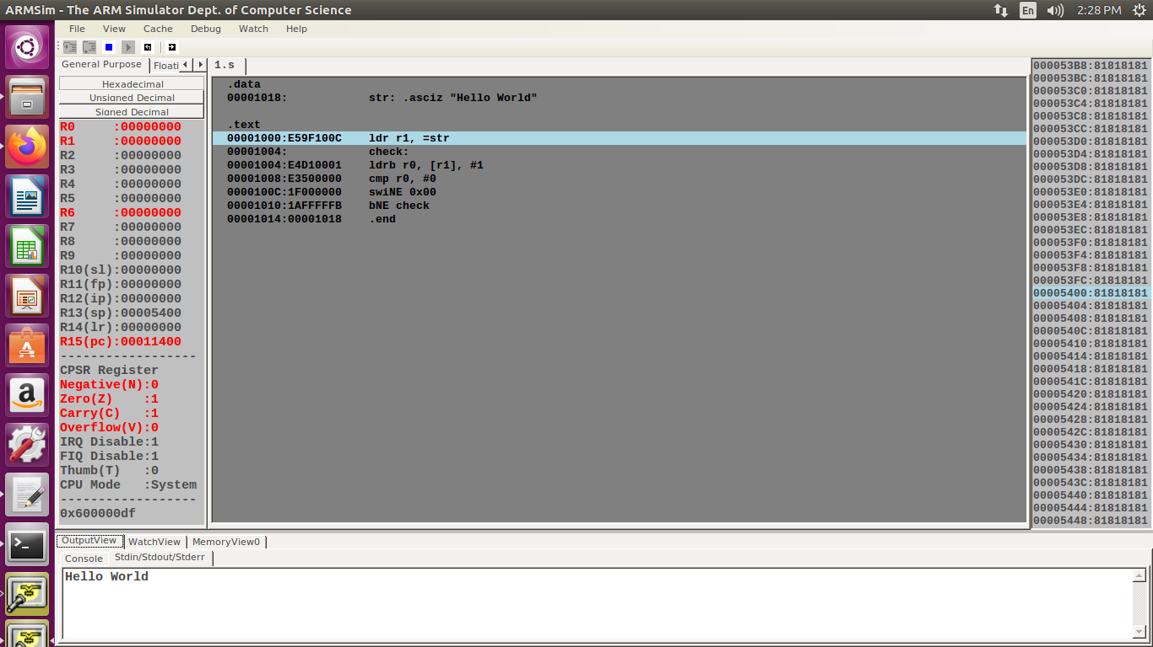

Program Number: 2

**Write an ALP to find the length of a given string**

1. ARM Assembly Code

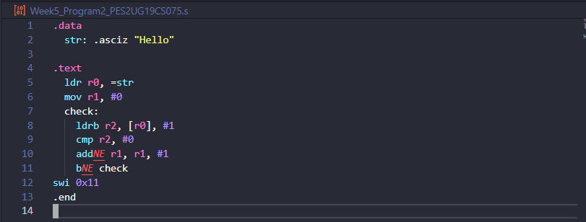

1. Output Screen Shot

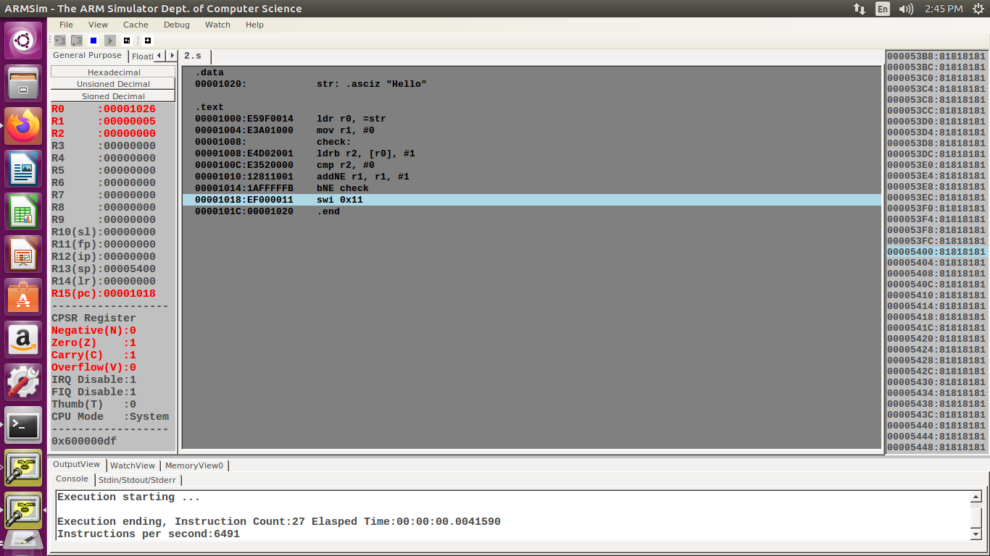

Program Number: 3

**Write an ALP to copy string from one location to another**

1. ARM Assembly Code

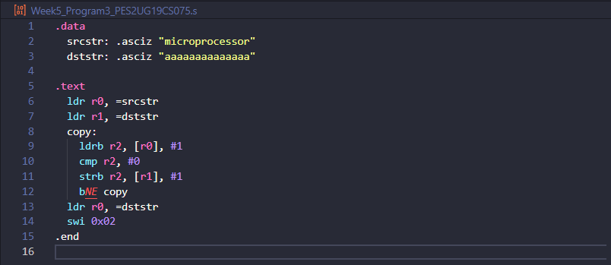

1. Output Screen Shot

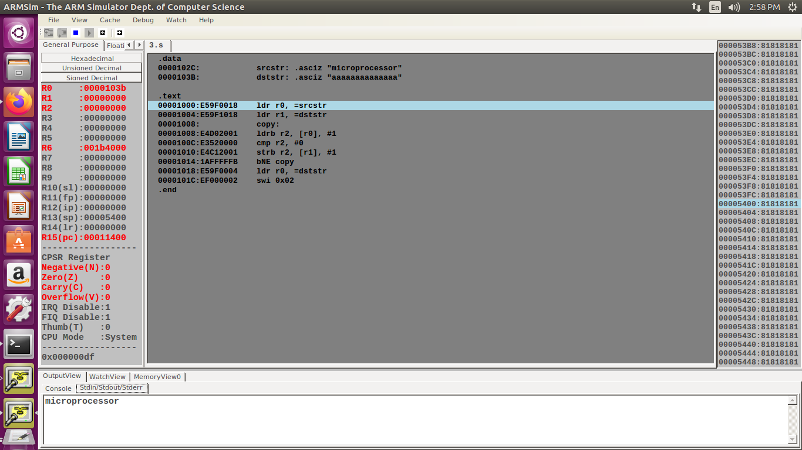

Program Number: 4

**Write an ALP to find whether a given character is present in a string. If present, find how many times the given character is present in a string.**

1. ARM Assembly Code

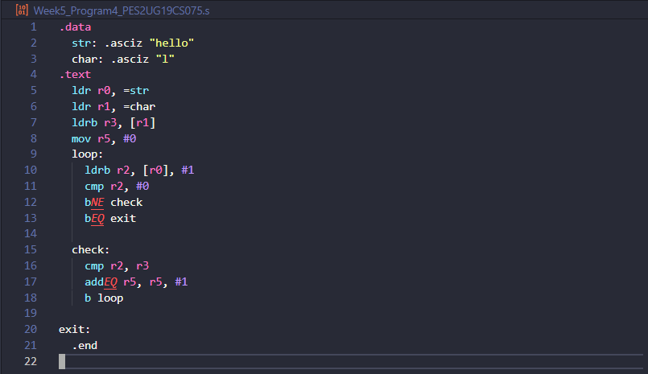

1. Output Screen Shot

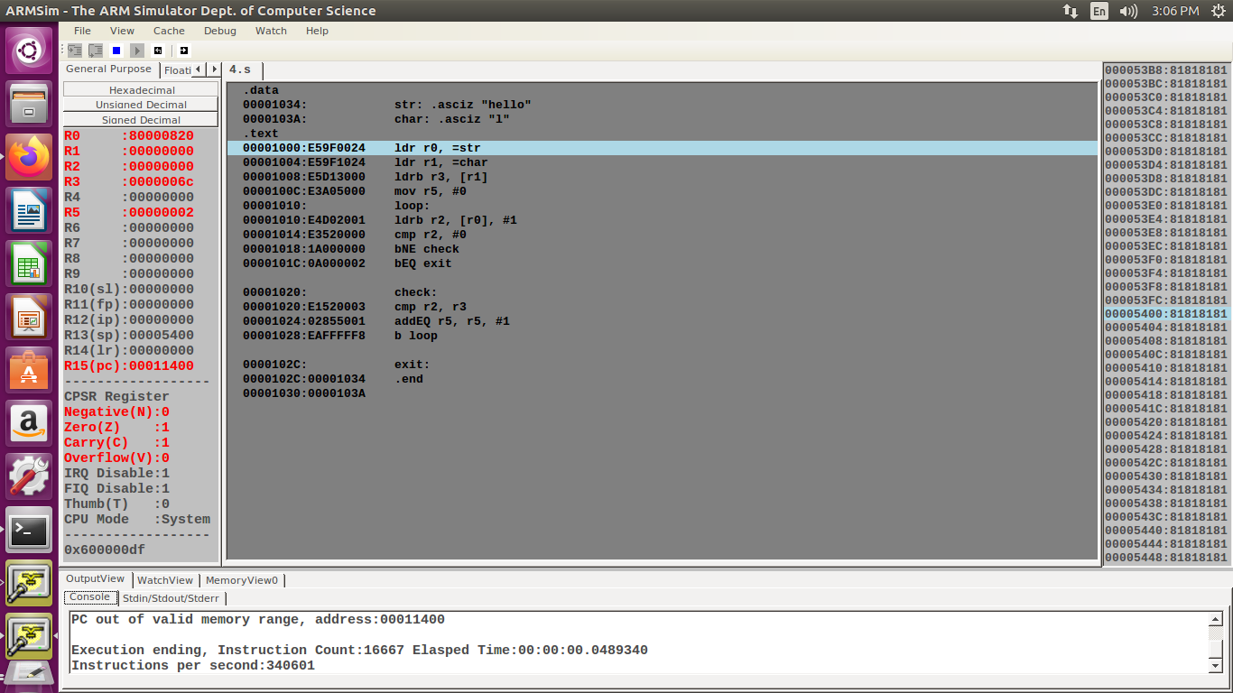

**Disclaimer:**

* The programs and output submitted is duly written, verified and executed by me.
* I have not copied from any of my peers nor from the external resource such as internet.
* If found plagiarized, I will abide with the disciplinary action of the University.

Signature: Atul Anurag

Name: **Atul Anurag**

SRN: **PES2UG19CS075**

Section: **B**

Date: **04-03-2021**